DOCUMENTATION

By

Usama usman & Ghani Baig

**ACKNOWLEDGMENT**

We are really grateful because we managed to complete our E-project within the time given by our teacher **Sir Amjad**. This assignment cannot be completed without the effort and co-operation from our group members, Group members; **Usama usman** and Ghani Baig**.**

We also sincerely thank our teacher **Sir Amjad** for the guidance and encouragement in finishing this project and also for teaching us in this course.

Last but not the least, we would like to express our gratitude to our friends and respondents for the support and willingness directly or indirectly to spend some times with us to fill in the questionnaires.

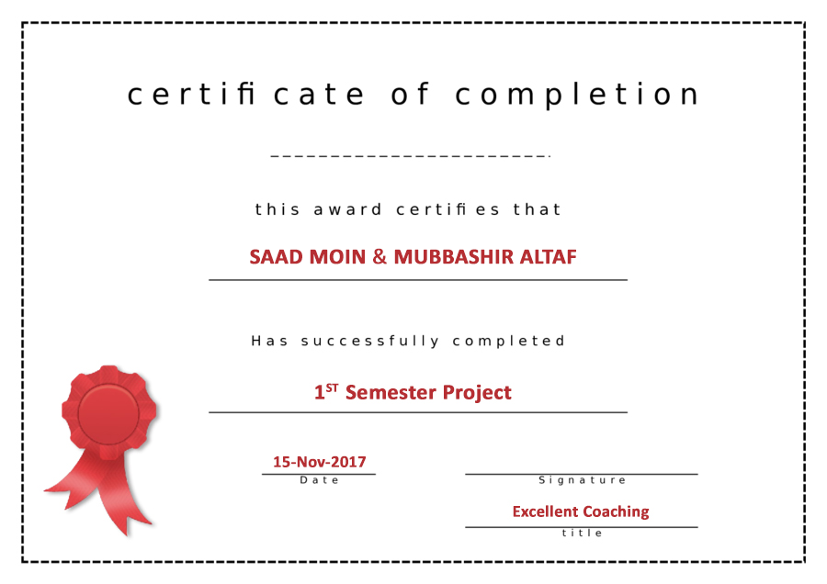

**CONTENT**

1. Introduction------------------------------------------------- 5
2. Objectives of the Project-------------------------------7
3. Topic of our Project--------------------------------------- 8
4. Hardware/Software Requirements------------------ 9
5. Work Analysis----------------------------------------------- 10
6. Design -------------------------------------------------------- 11
7. Homepage ------------------------------------------------- 12
8. Header -------------------------------------------------------- 15
9. Navigation Bar ---------------------------------------------- 17
10. Slider ---------------------------------------------------------- 18
11. Courses ------------------------------------------------------ 19
12. Footer -------------------------------------------------------- 25
13. Contact Us ------------------------------------------------- 26
14. Flowchart for Contact Us -------------------------------- 29
15. Faculty ------------------------------------------------------- 31
16. Fees ----------------------------------------------------------- 33
17. About Us ---------------------------------------------------- 36

1. **Introduction**

The thirst for learning, upgrading technical skills and applying the concepts in real life environment at a fast pace is what the industry demands from IT professionals today. However busy work schedules, far-flung locations, unavailability of convenient time-slots pose as major barriers when it comes to applying the concepts into realism. And hence the need to look out for alternative means of implementation in the form of laddered approach.

The above truly pose as constraints especially for our students too! With their busy schedules, it is indeed difficult for our students to keep up with the genuine and constant need for integrated application which can be seen live especially so in the field of IT education where technology can change on the spur of a moment. *Well, technology does come to our rescue at such times!!*

Keeping the above in mind and in tune with our constant endeavour to use Technology in our training model, we at Aptech have thought of revolutionizing the way our students learn and implement the concepts using tools themselves by providing a *live and synchronous eProject learning environment!*

**So what is this eProject?**

eProject is a step-by-step learning environment that closely simulates the classroom and Lab based learning environment into actual implementation. It is a project implementation at your fingertips!! An electronic, live juncture on the machine that allows you to

* Practice step by step i.e. laddered approach.
* Build a larger more robust application.
* Usage of certain utilities in applications designed by user.
* Single program to unified code leading to a complete application.
* Learn implementation of concepts in a phased manner.
* Enhance skills and add value.
* Work on real life projects.
* Give a real life scenario and help to create applications more complicated and useful.
* Mentoring through email support.

The students at the centre are expected to complete this eProject and send complete project along with the documentation to eprojects@aptechfze.ae

Looking forward to a positive response from your end!!

1. **Objectives of the project**

The Objective of this program is to give a sample project to work on real life projects. These applications help you build a larger more robust application.

The objective is not to teach you JavaScript/Dreamweaver but to provide you with a real life scenario and help you create basic applications using the tools.

You can revise the chapters before you start with the project.

This project is meant for students who have completed the module of ***Dreamweaver***. These programs should be done in the Lab sessions with assistance of the faculty if required.

It is very essential that a student has a clear understanding of the subject. Students should go through the project and solve the assignments as per requirements given.

Kindly get back @ eprojects@aptechfze.ae in case of any doubts regarding the application or its objectives.

1. **Topic of Our Project**

**Excellent Coaching**

**Problem Statement**

Excellent Coaching is into business for more than a decade. They have been advertising about their coaching classes through newspapers, pamphlets, television. Now with changing times, they have decided to go online as most of the students today are frequent users of Internet. They have planned for a website with complete details about the Coaching classes.

**Requirement Specification:**

The Web site is to be created based on the following requirements.

1. The Home Page should be created making use of Sections with a suitable logo, the header section can be added which will show images yachts and boats
2. The site must contain the links to navigate through any category for the information.
3. Links of fleets can be categorized like (Luxury, Sailing, Fishing etc.)
4. Specification and Pricing of Yacht/Boat can be added along with the images.
5. Gallery section can be added for viewing different images.
6. Feedback must be allowed to enter by the viewer
7. Site map, Gallery, about us, Queries link, Contact us link must be added.
8. The complete description must be allowed to get download as pdf or doc file.
9. The advertise section with various facilities provided should be mentioned.

1. **Hardware/ Software Requirements**

**Hardware**

* A minimum computer system that will help you access all the tools in the courses is a Pentium 166 or better
* 64 Megabytes of RAM or better

**Software**

* Notepad/HTML editor
* Dreamweaver
* IE 5.0/ Netscape 6.0

1. **WORK ANALYSIS**

|  |  |  |
| --- | --- | --- |
| Task | USAMA USMAN | GHANI BAIG |
| Analysis |  |  |
| Design |  |  |
| Coding |  |  |
| Testing |  |  |
| Documentation |  |  |

1. 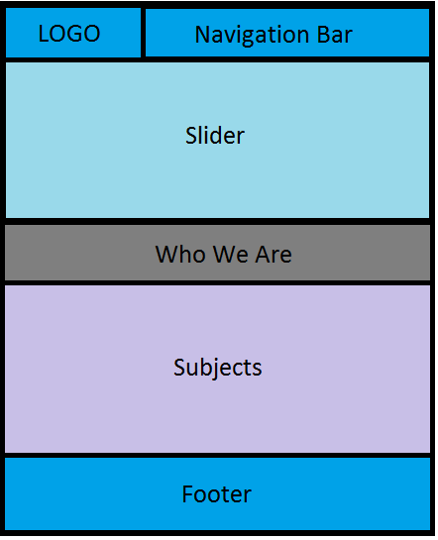**DESIGN**
2. **HOMEPAGE**

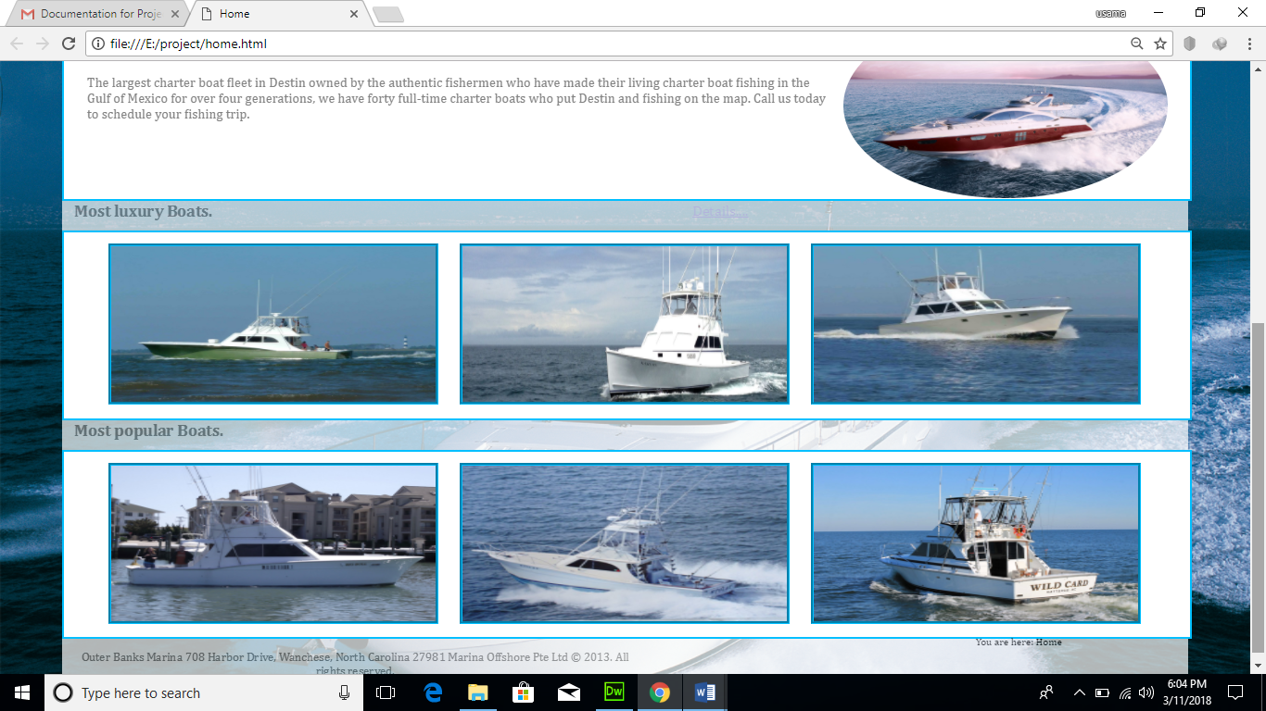

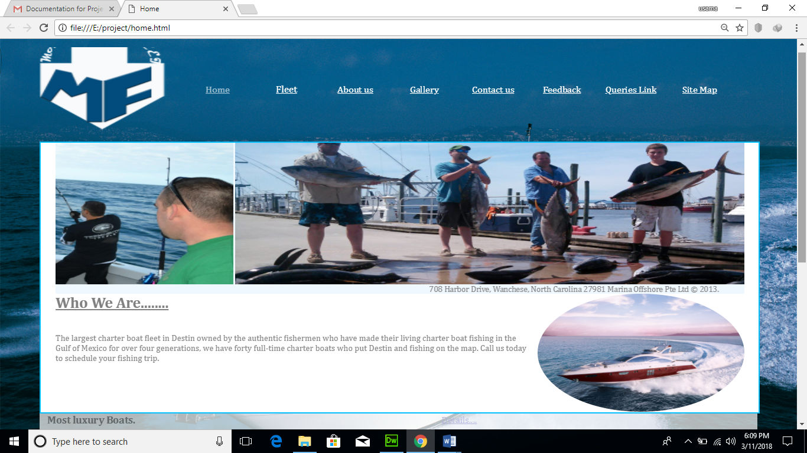

**HTML**

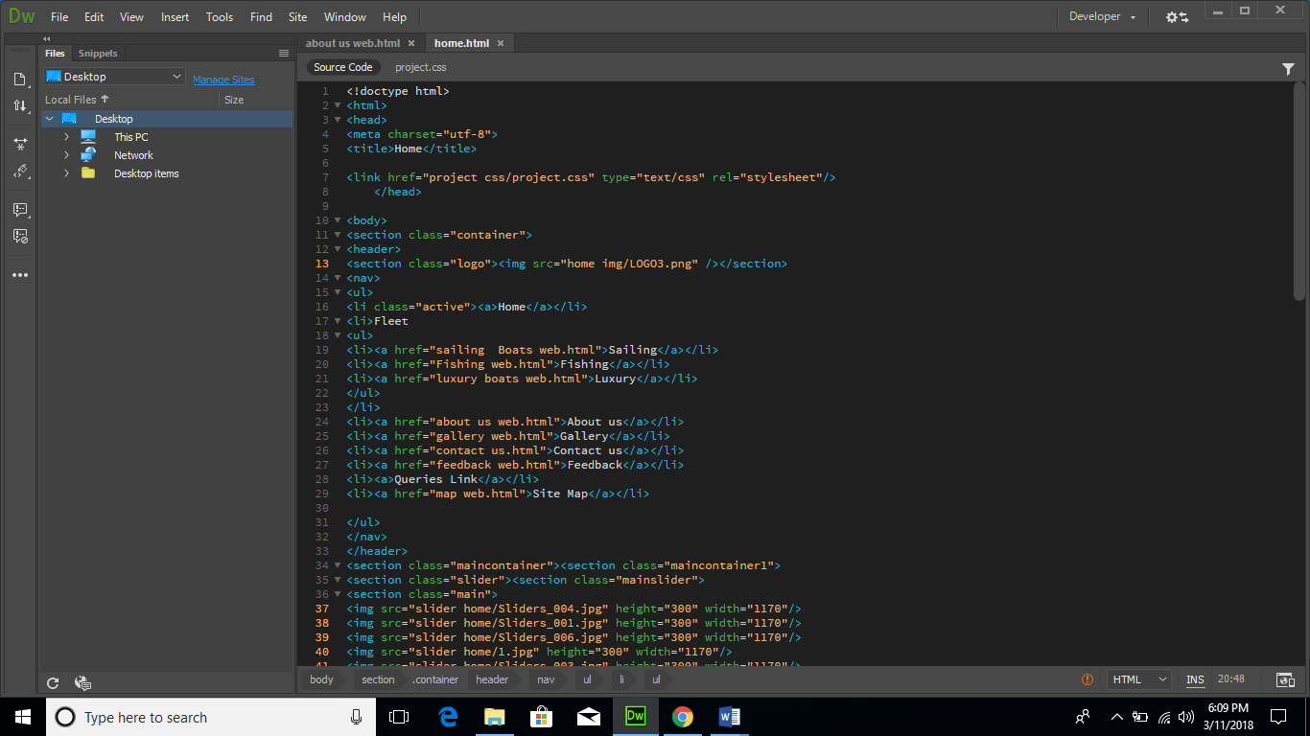

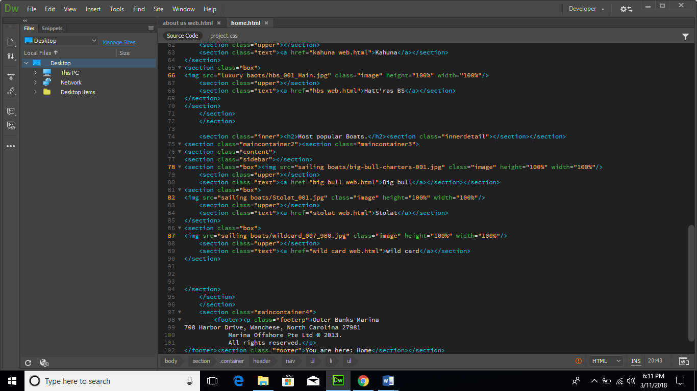

**CSS**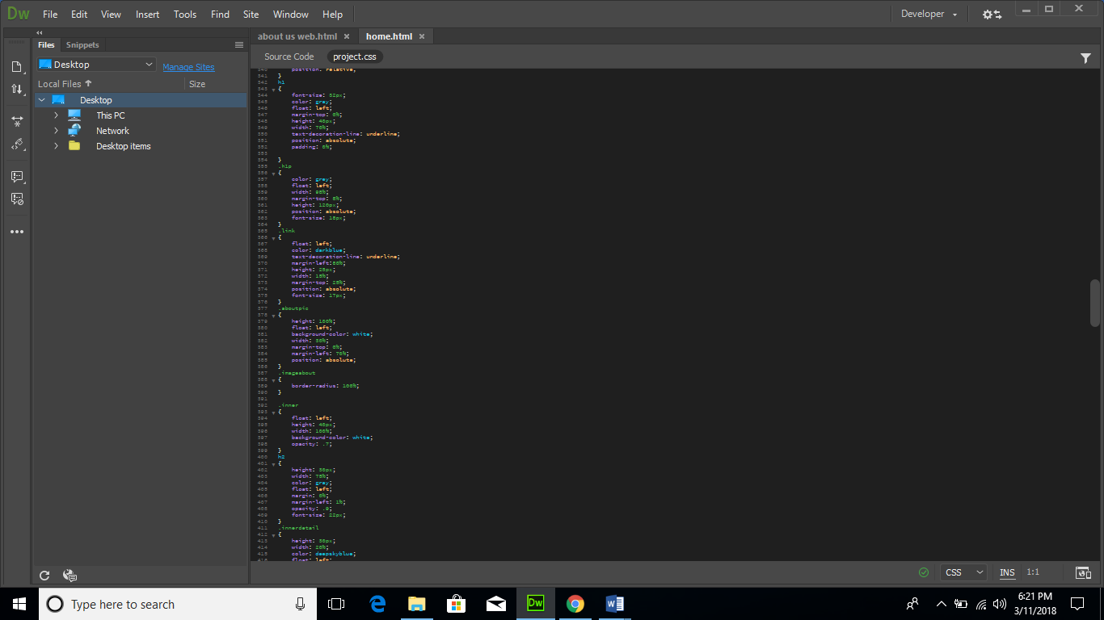

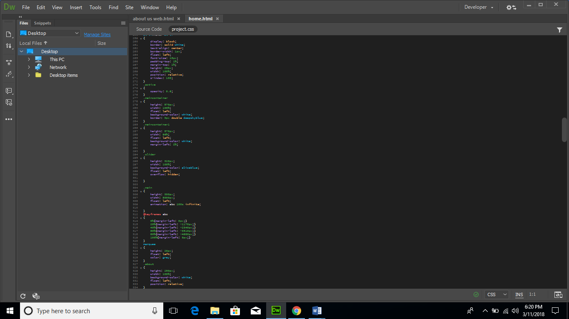

* + 1. **Header**

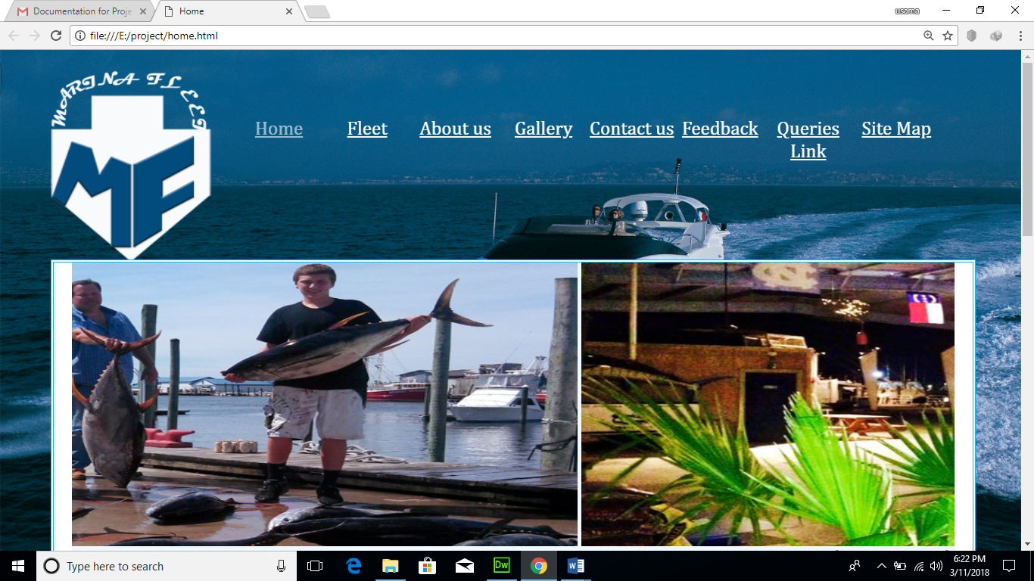

**HTML**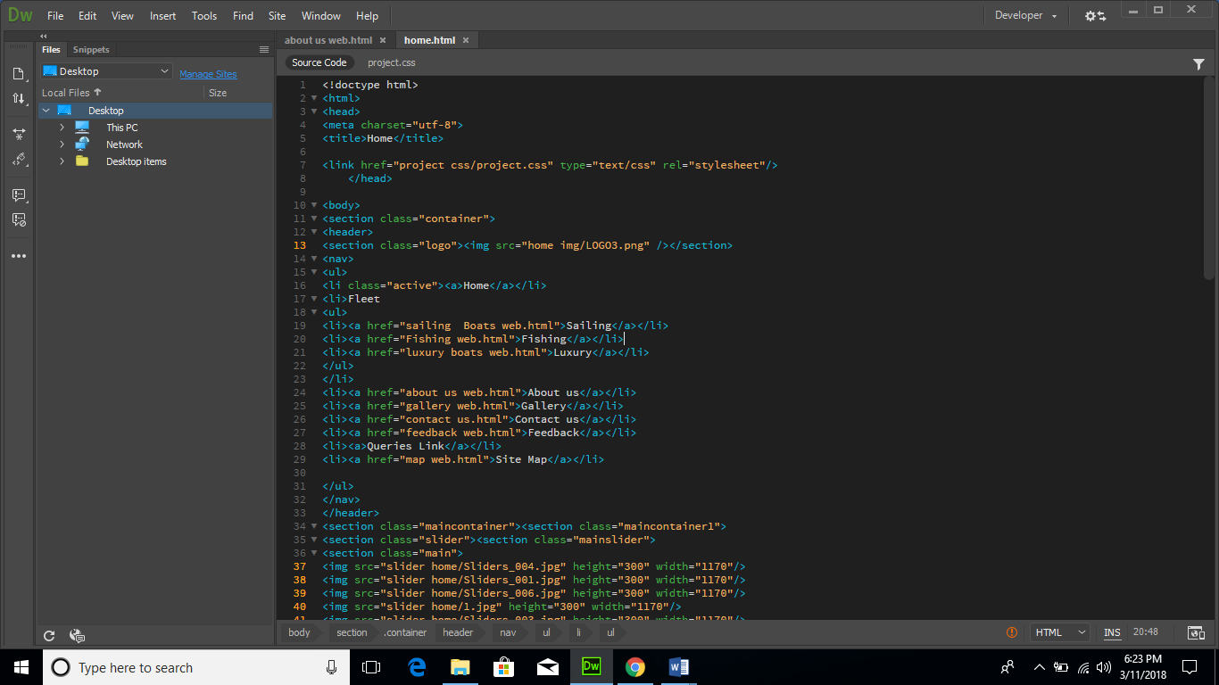

**CSS**

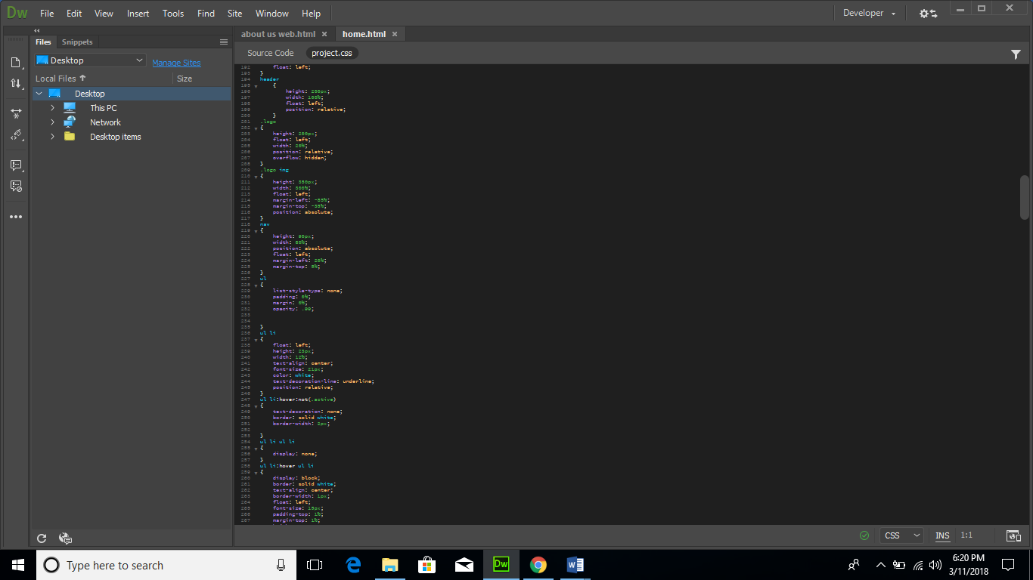

* + 1. **Navigation Bar**

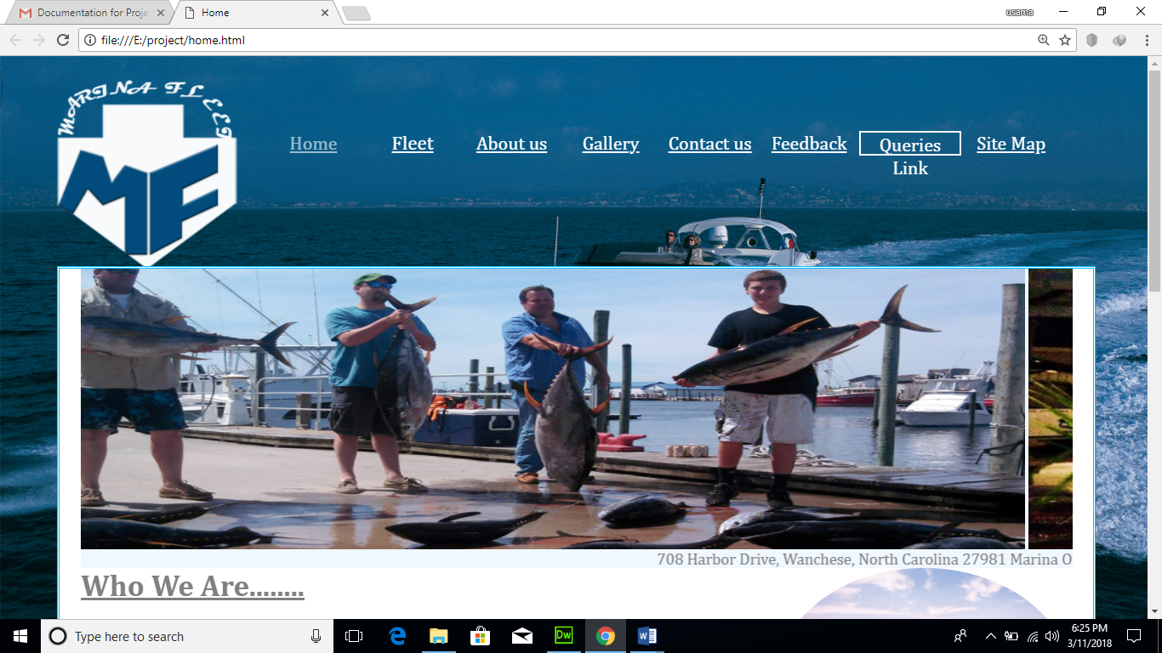

**HTML**

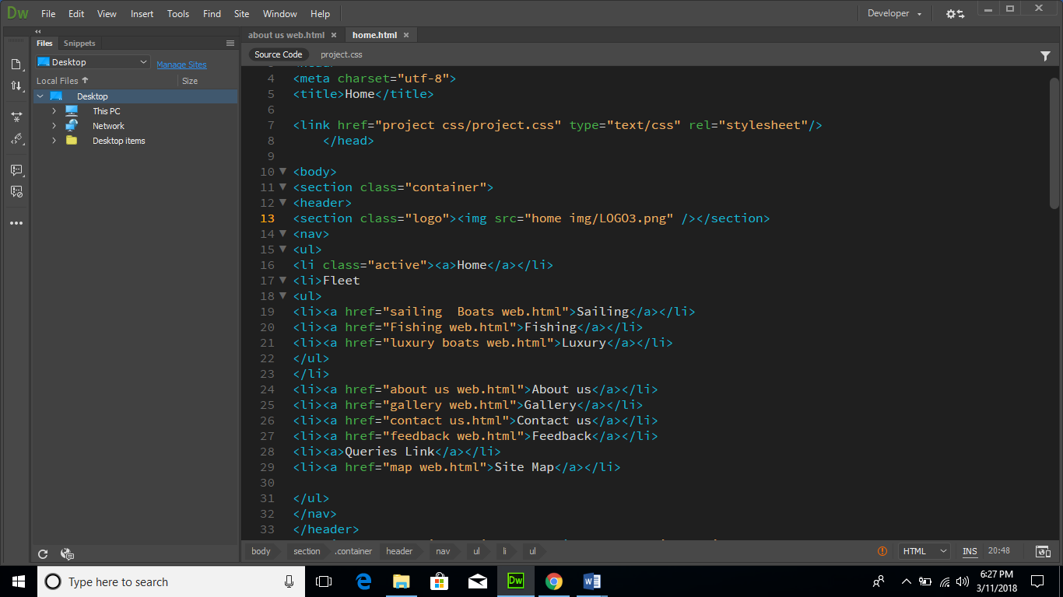

**CSS**

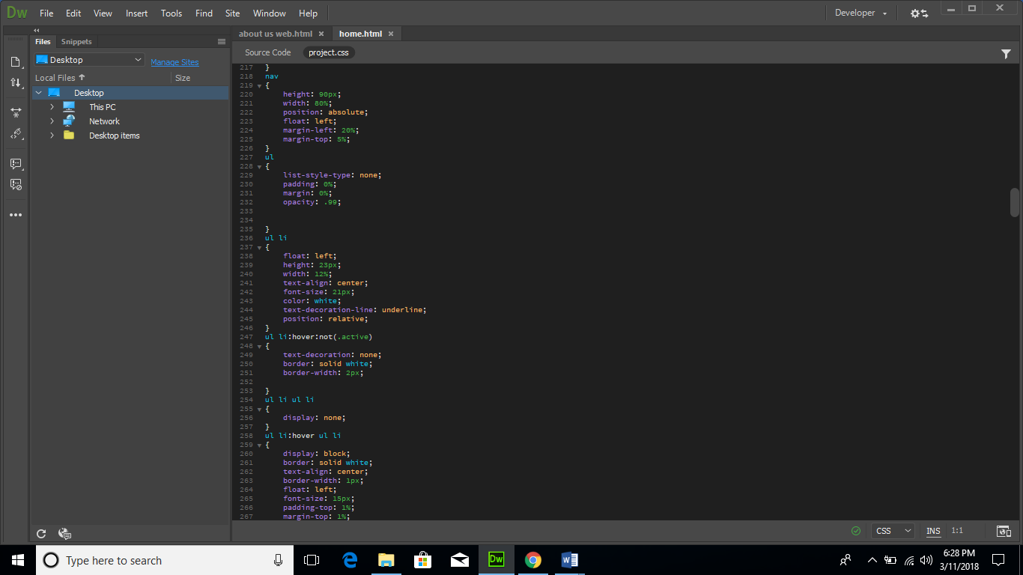

* + 1. **Slider**

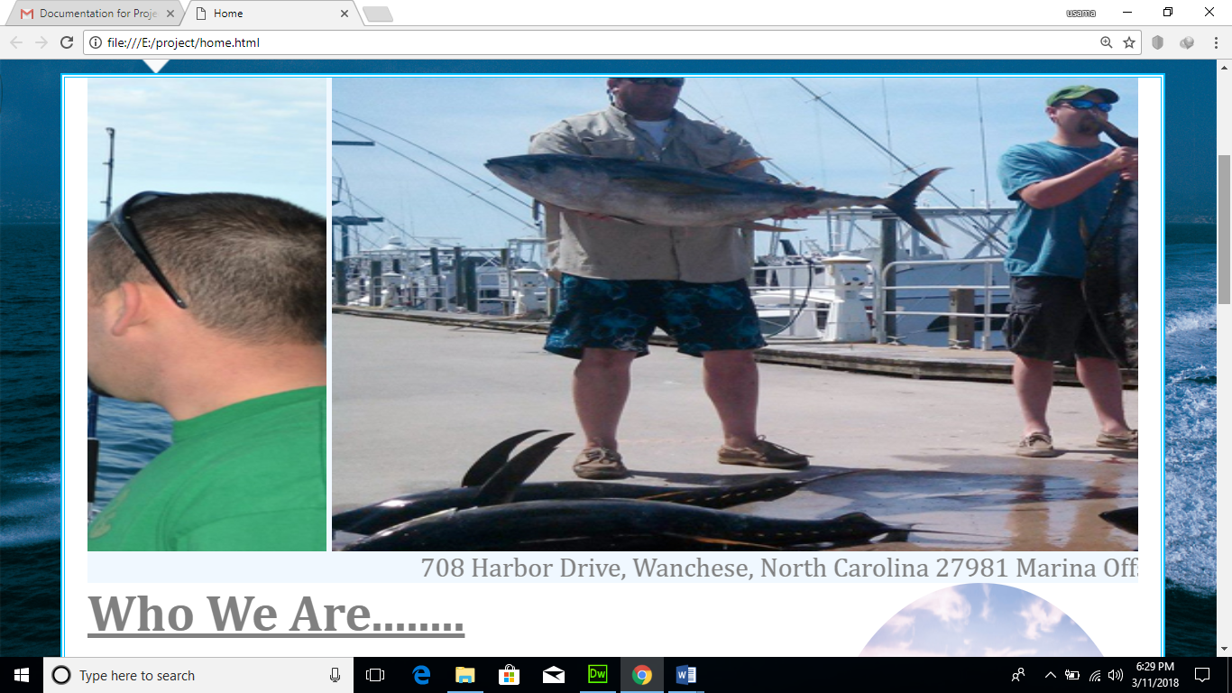

**HTML**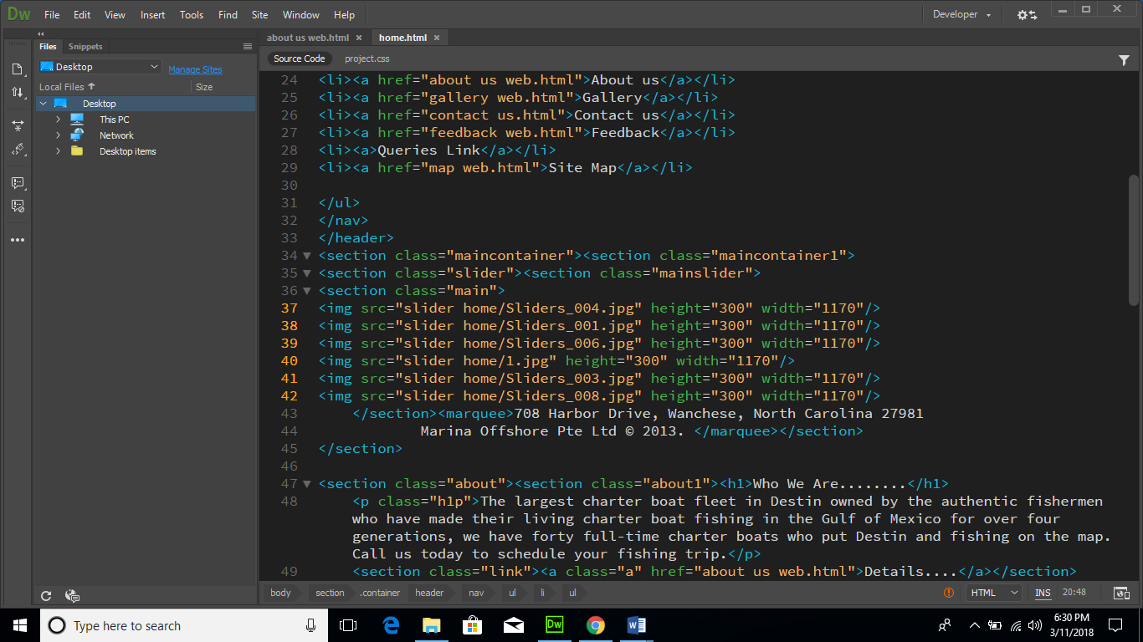

**CSS**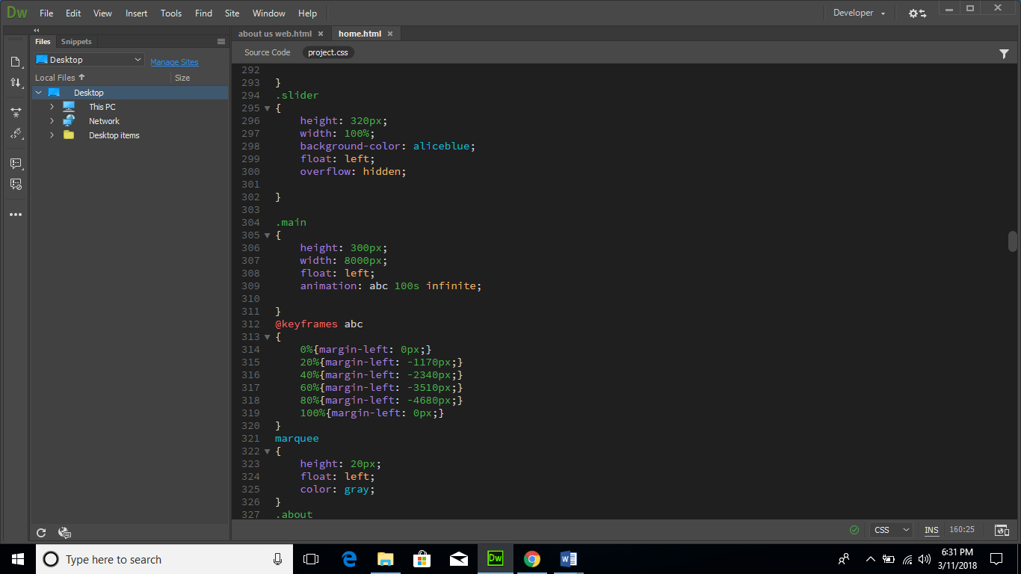

* + 1. **About**

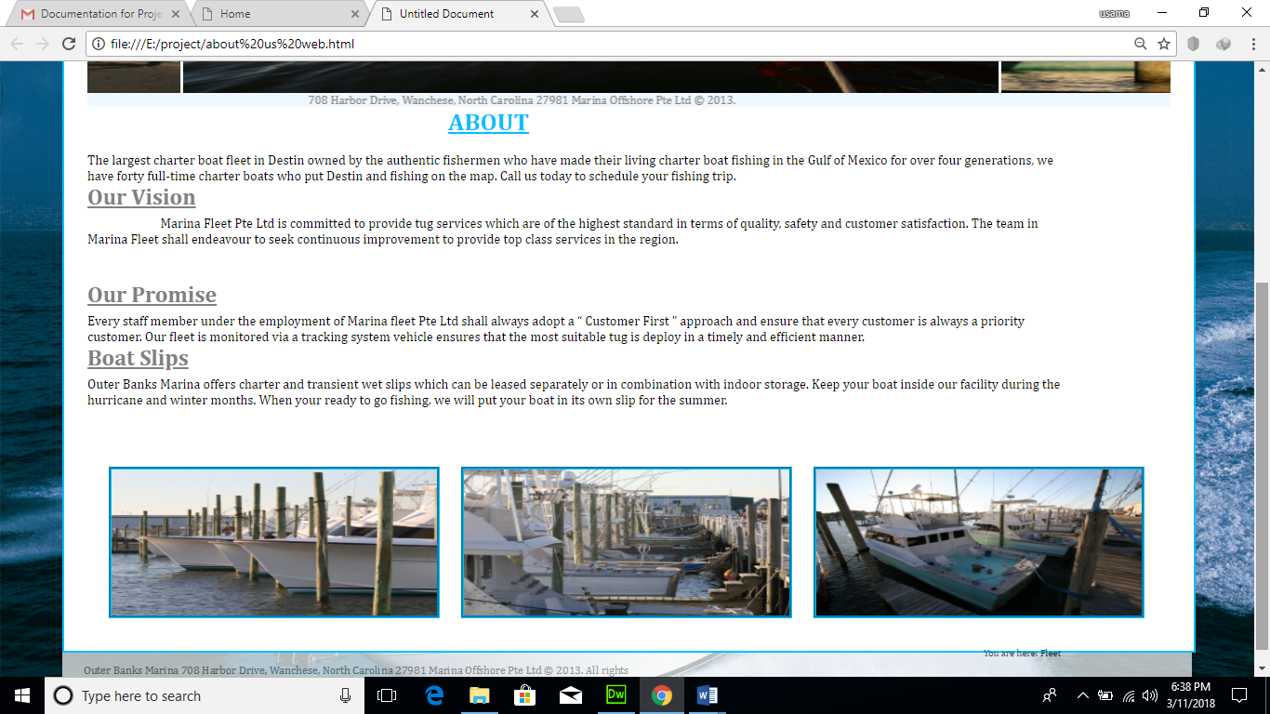

**HTML**

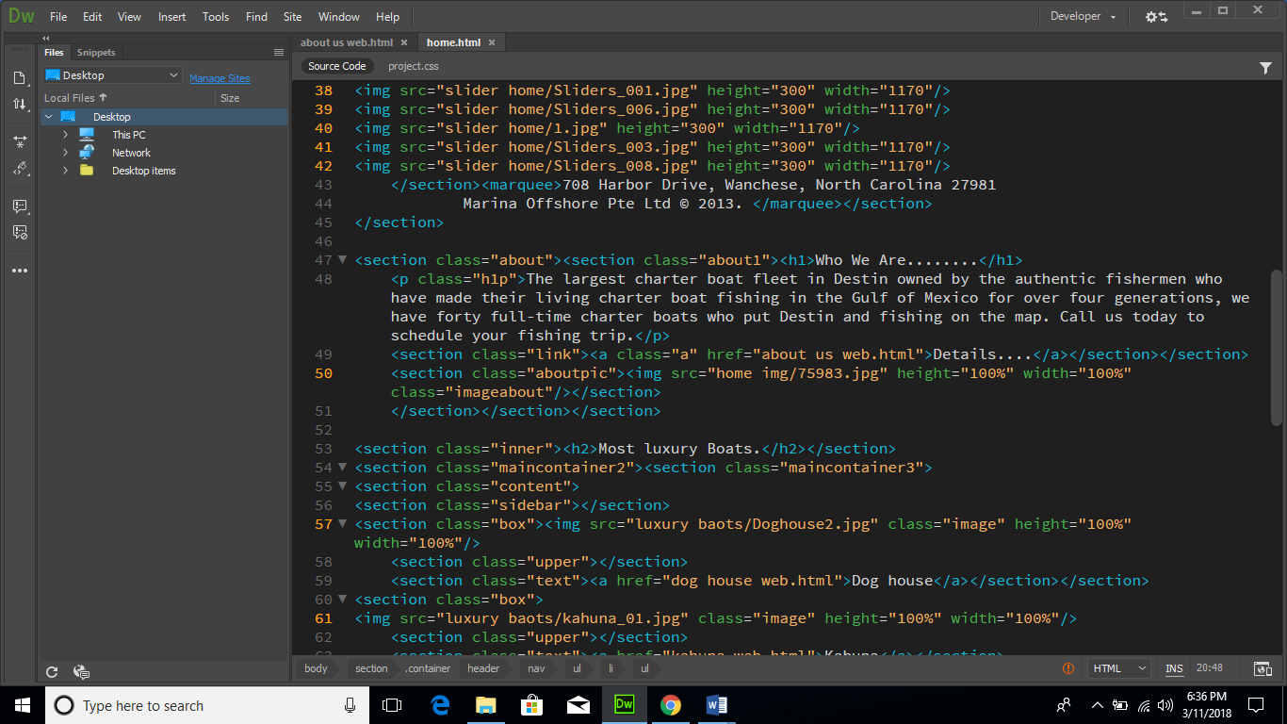

**CSS**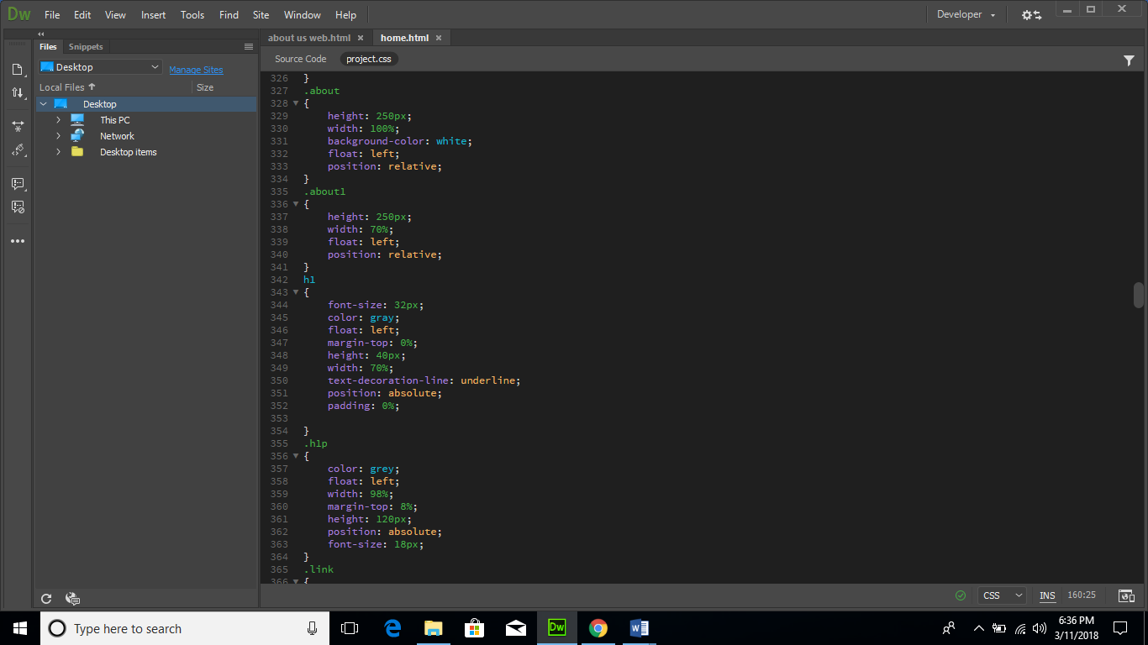

**FLEET**

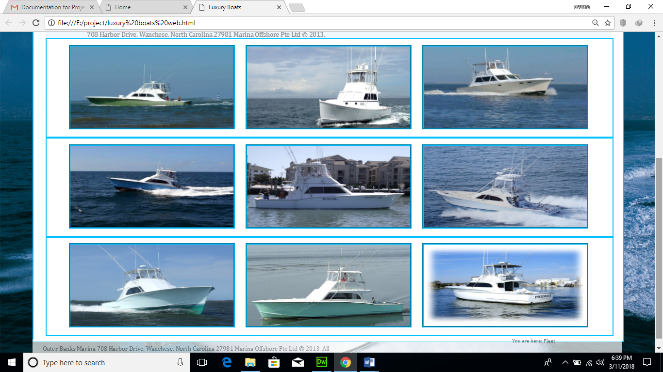

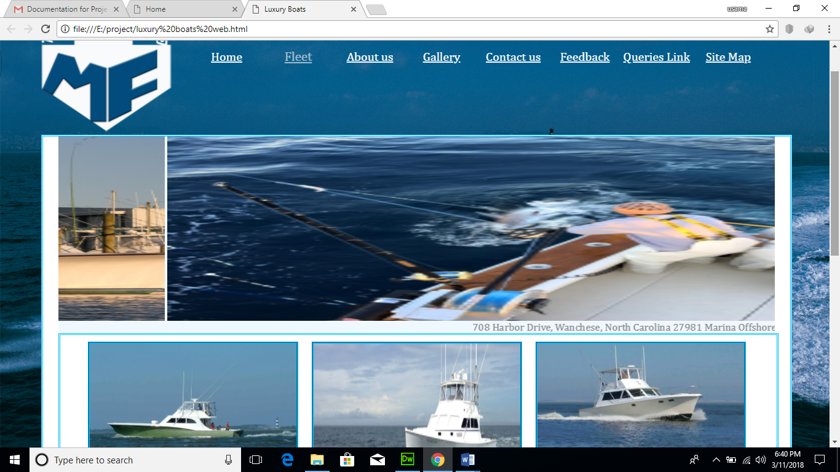

**HTML**

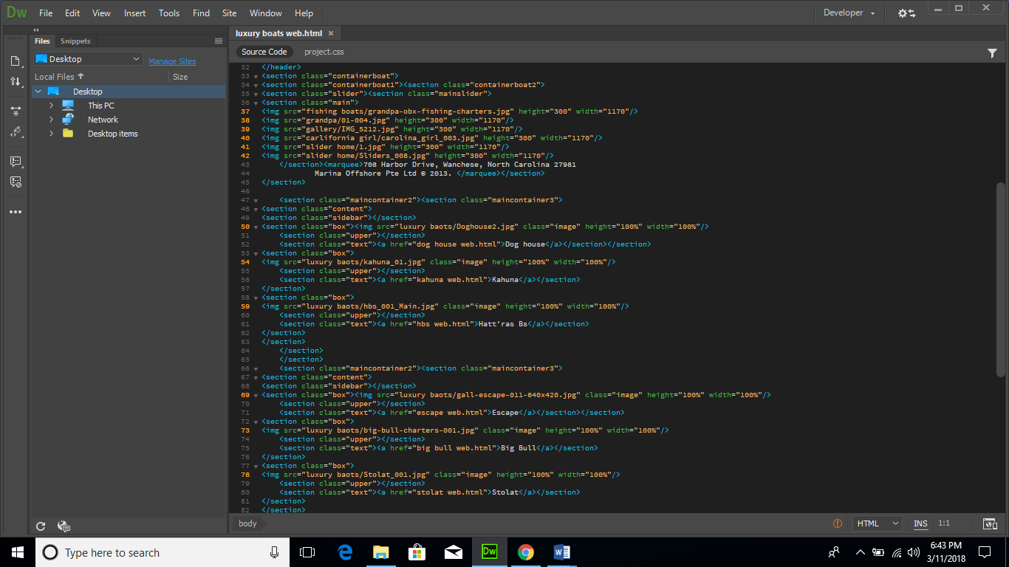

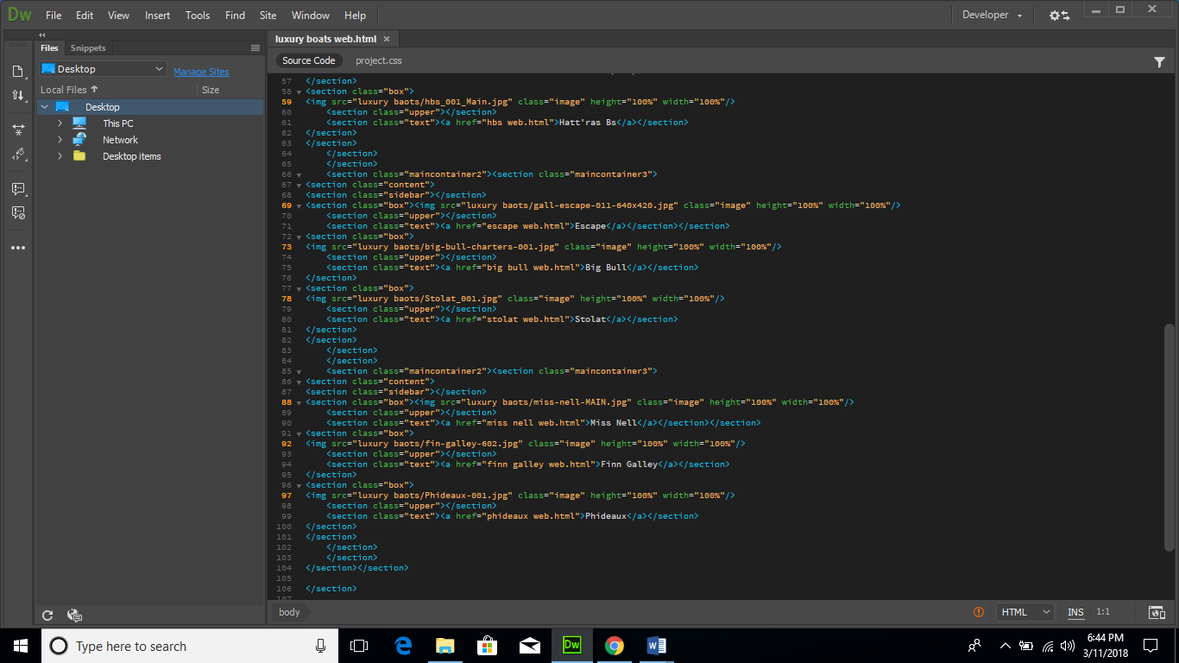

**CSS**

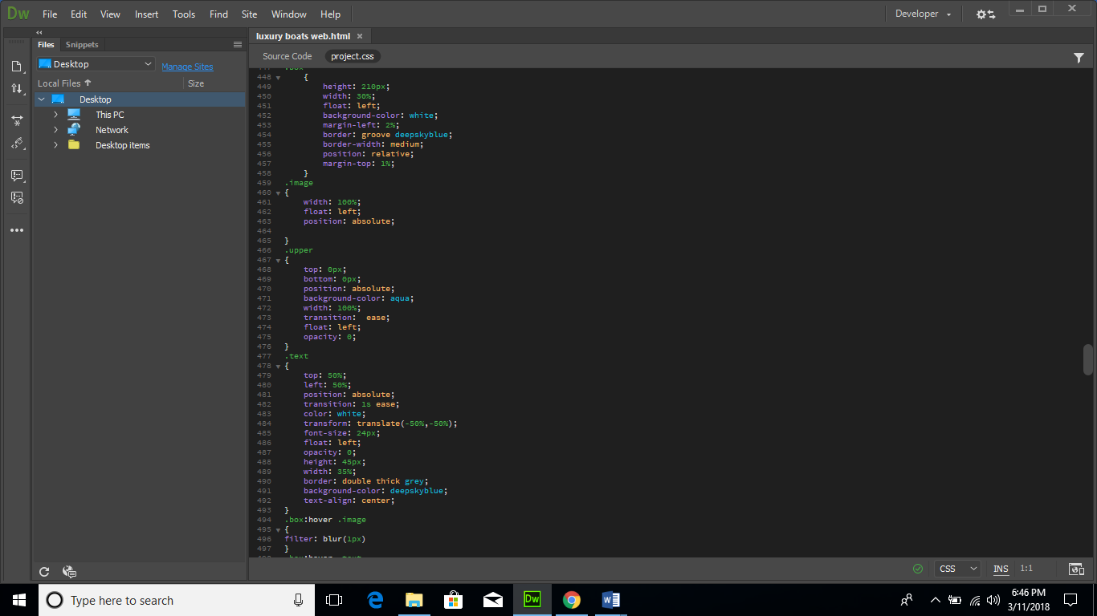

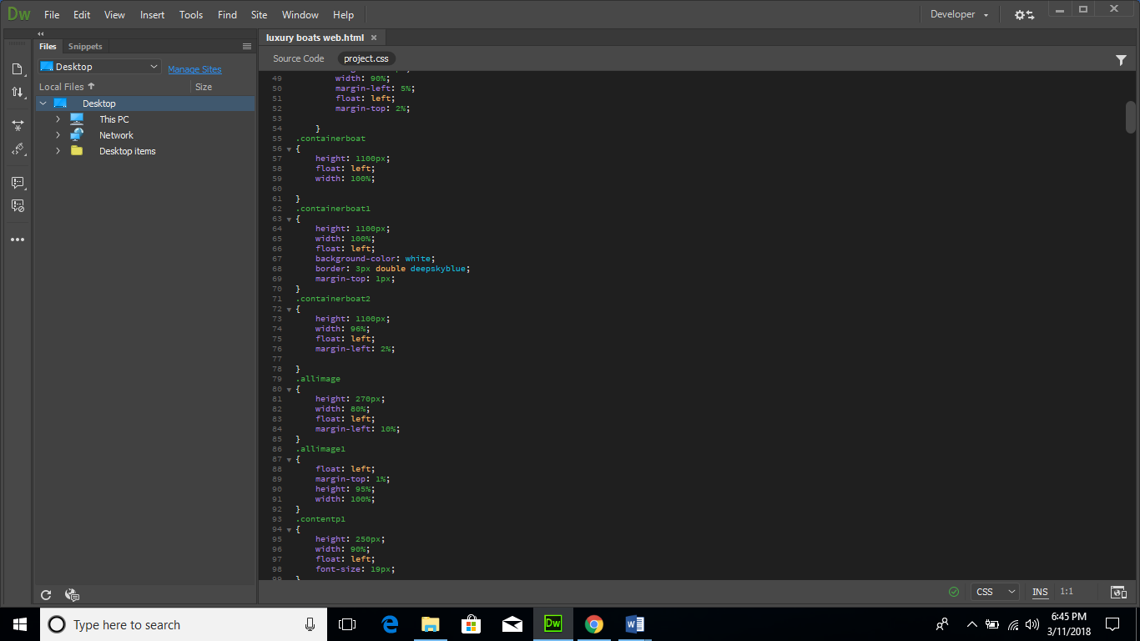

* + 1. **Footer**

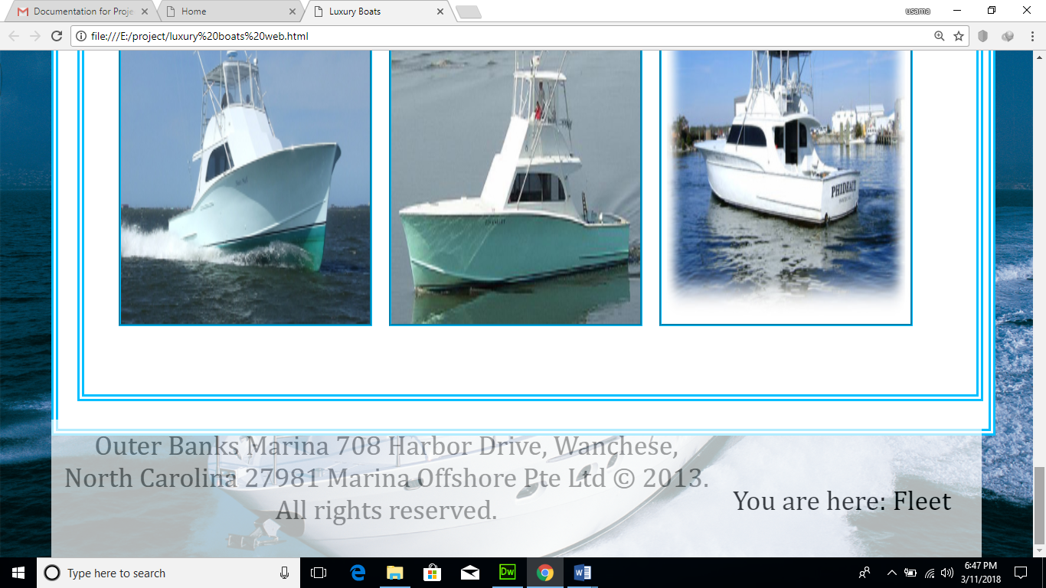

**HTML**

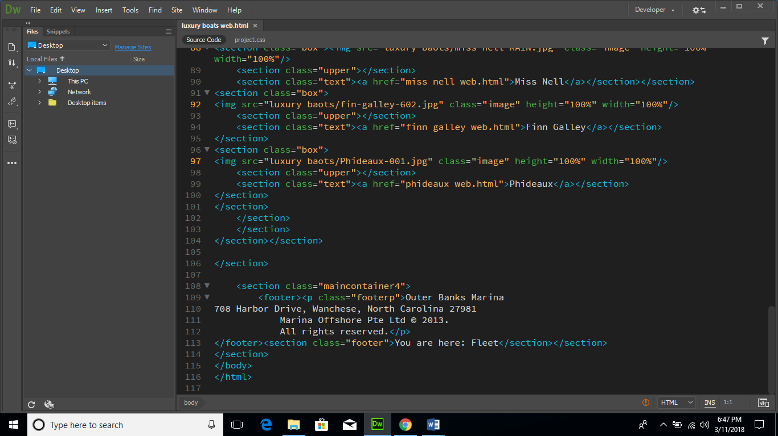

**CSS**

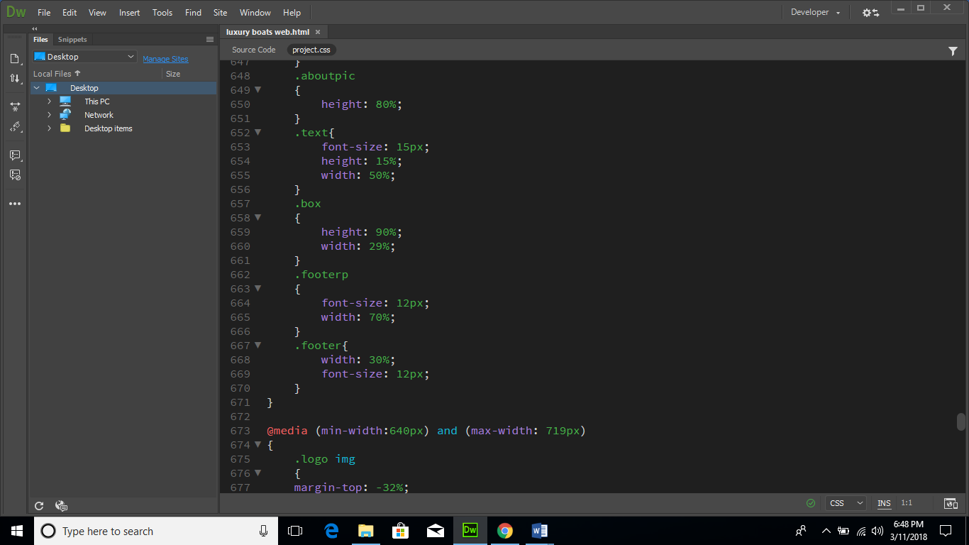

1. **CONTACT US**

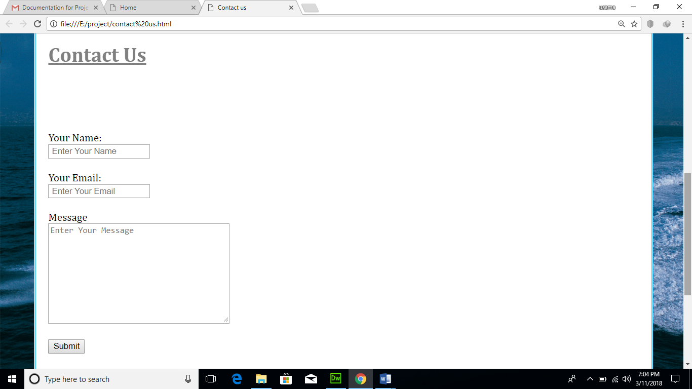

**HTML**

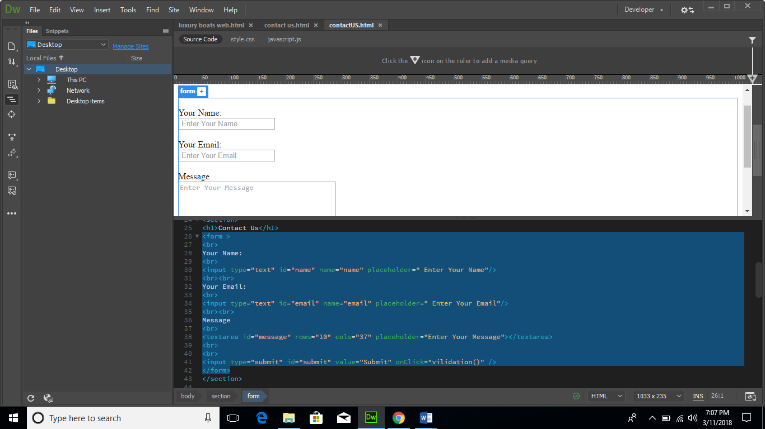

**JAVASCRIPT**

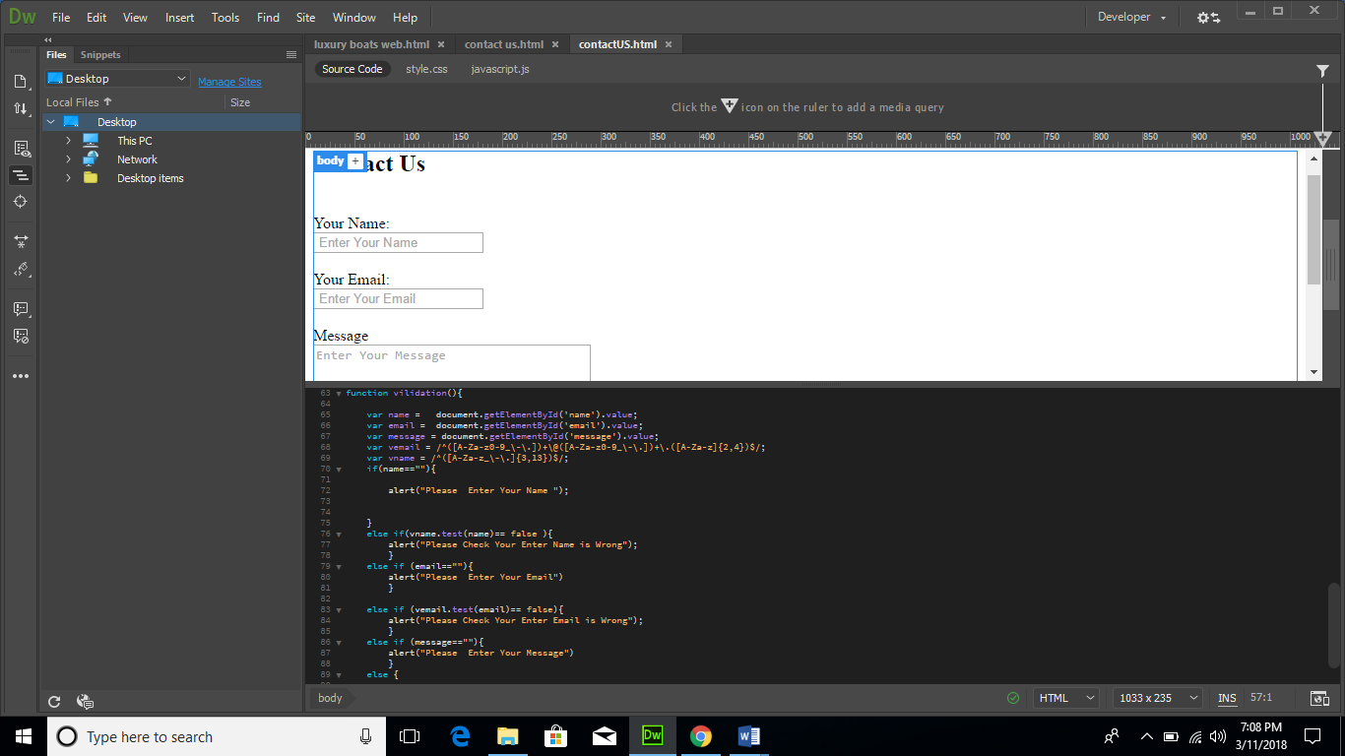

1. 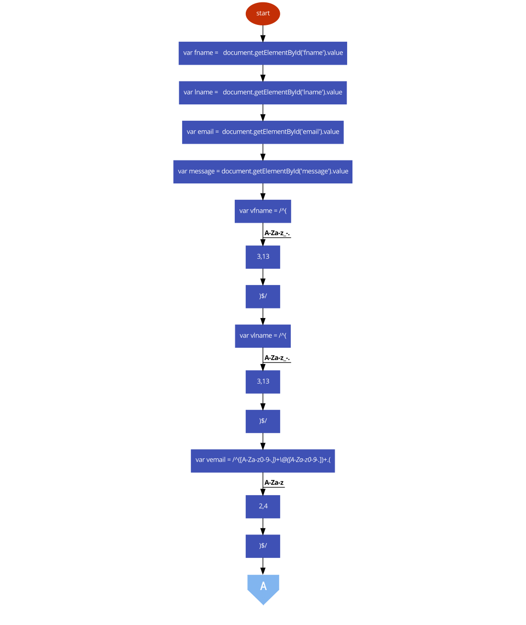**FLOWCHART FOR CONTACT US**

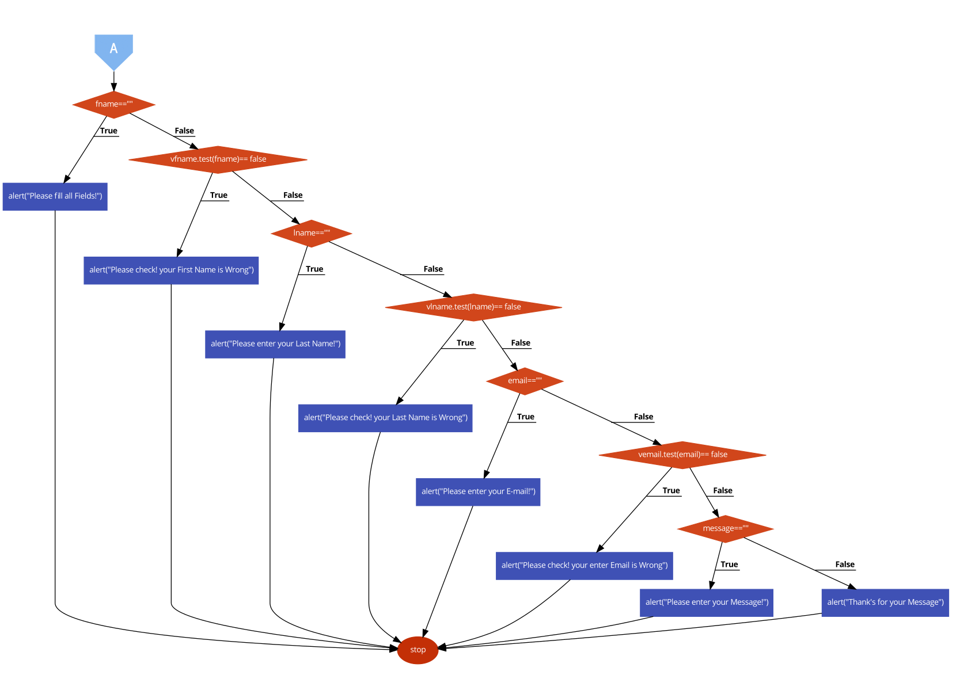

1. **GALLERY**

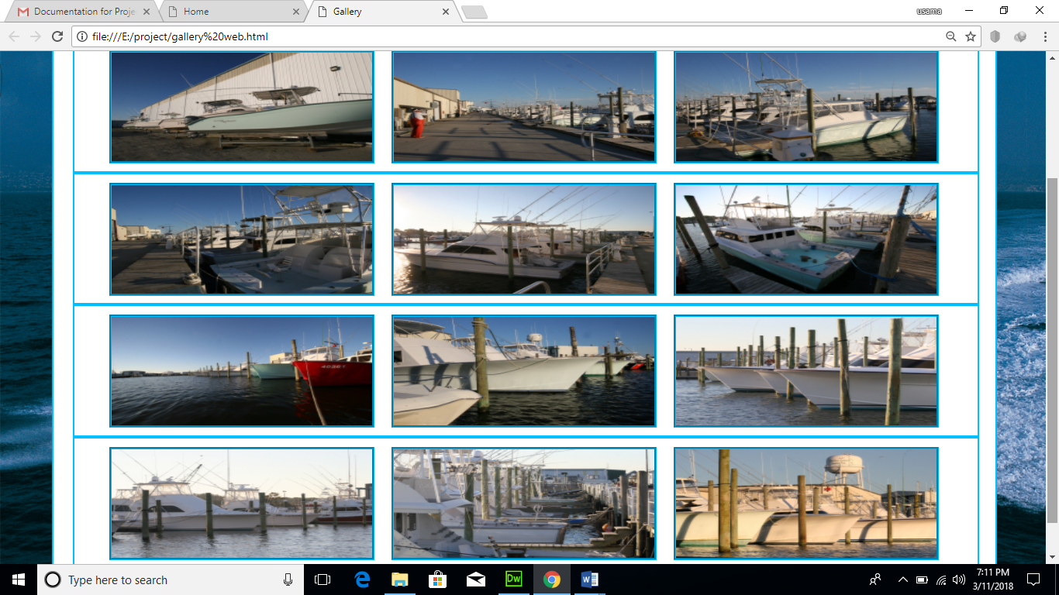

**HTML**

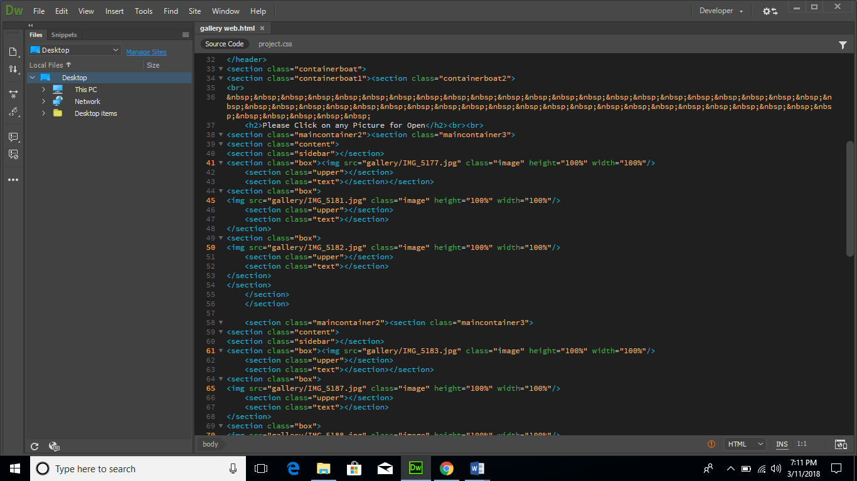

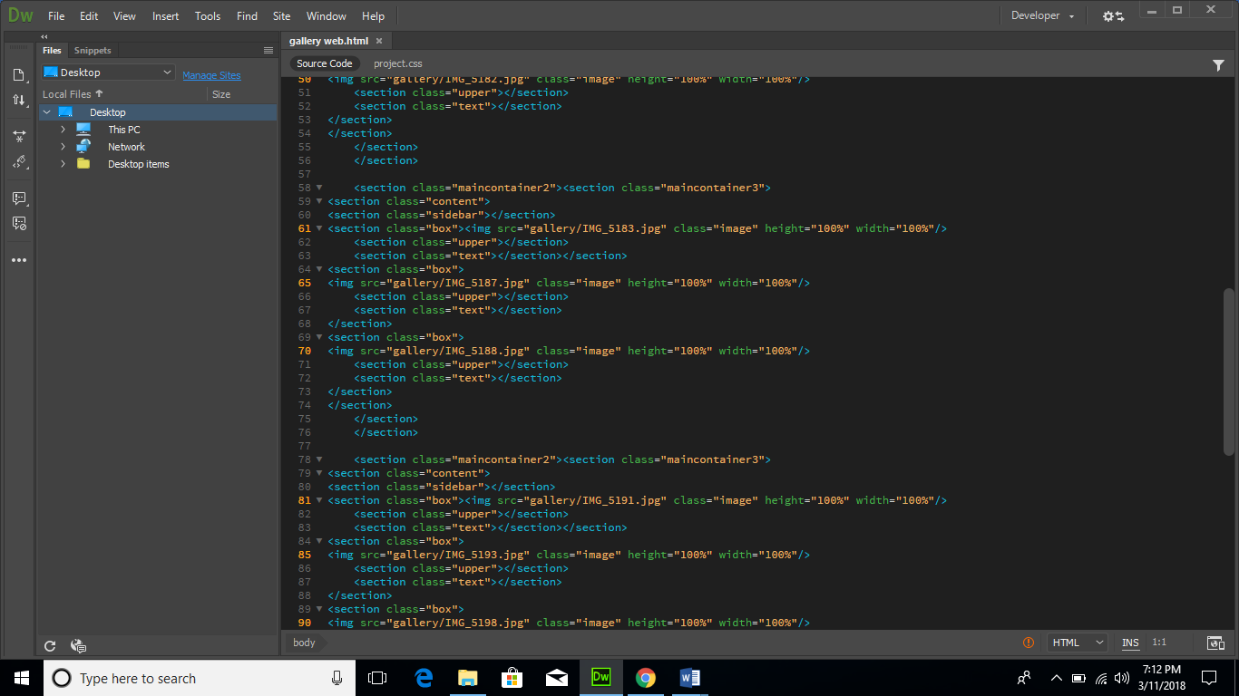

**CSS**

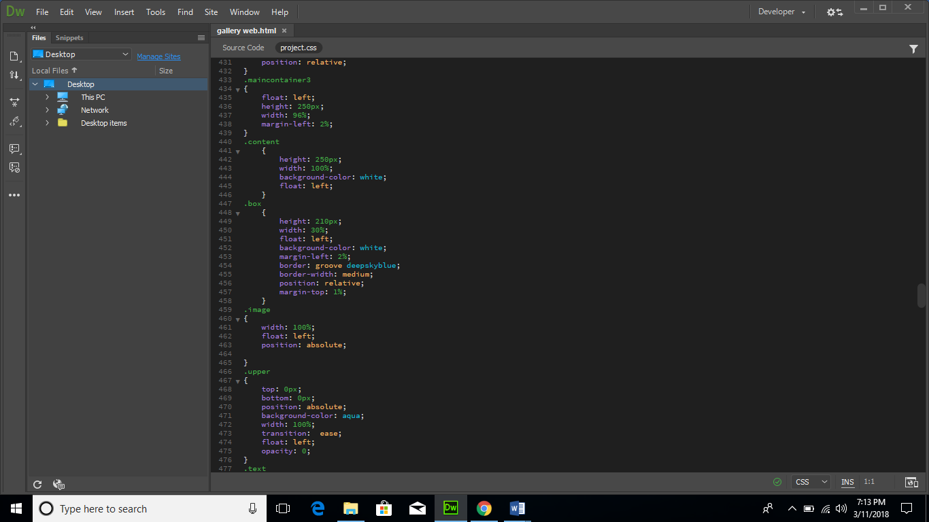

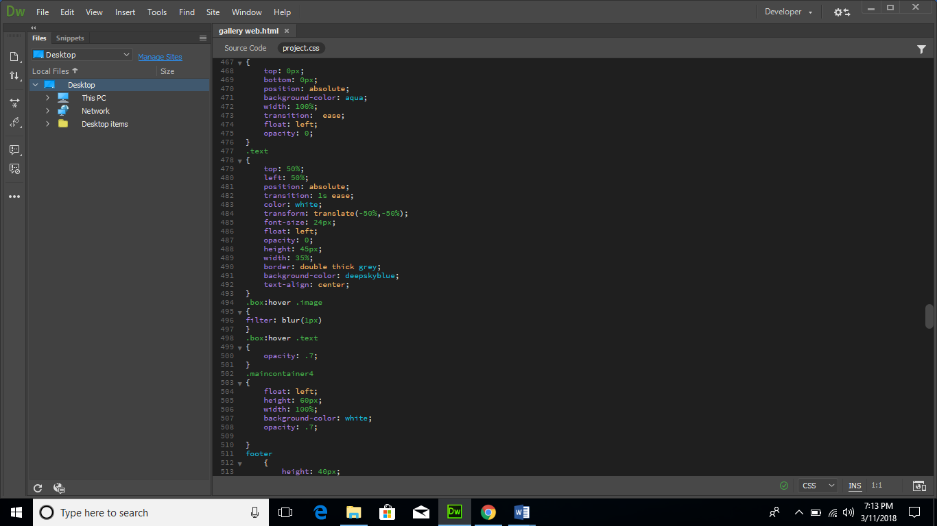

1. **Feedback**

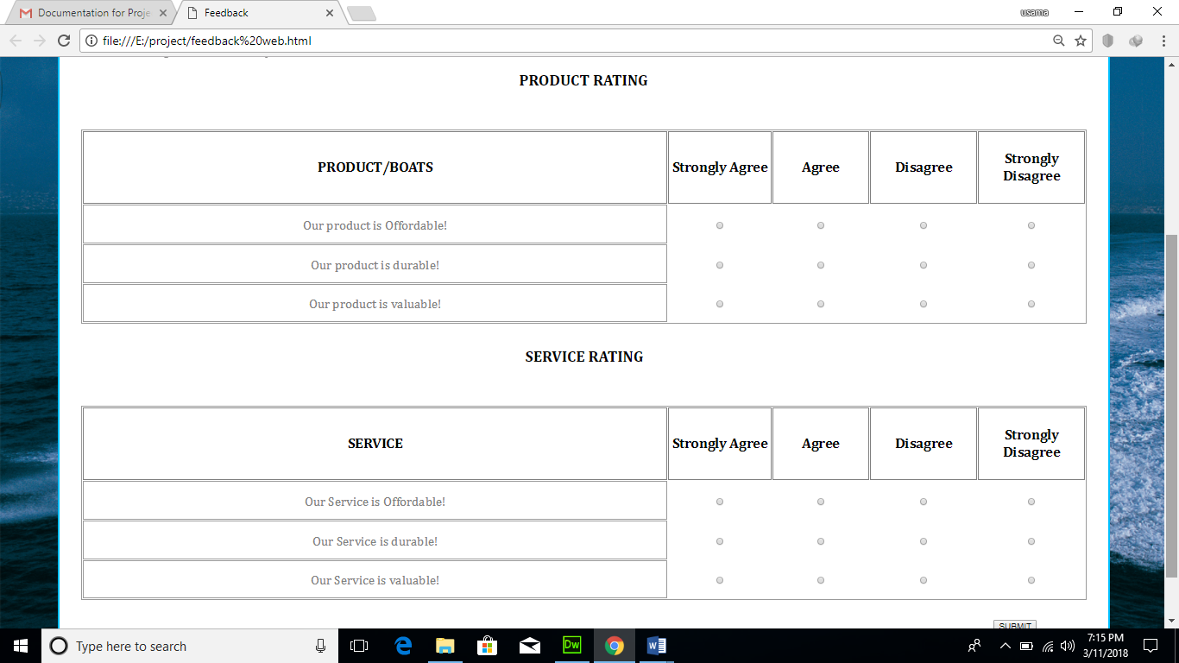

**HTML**

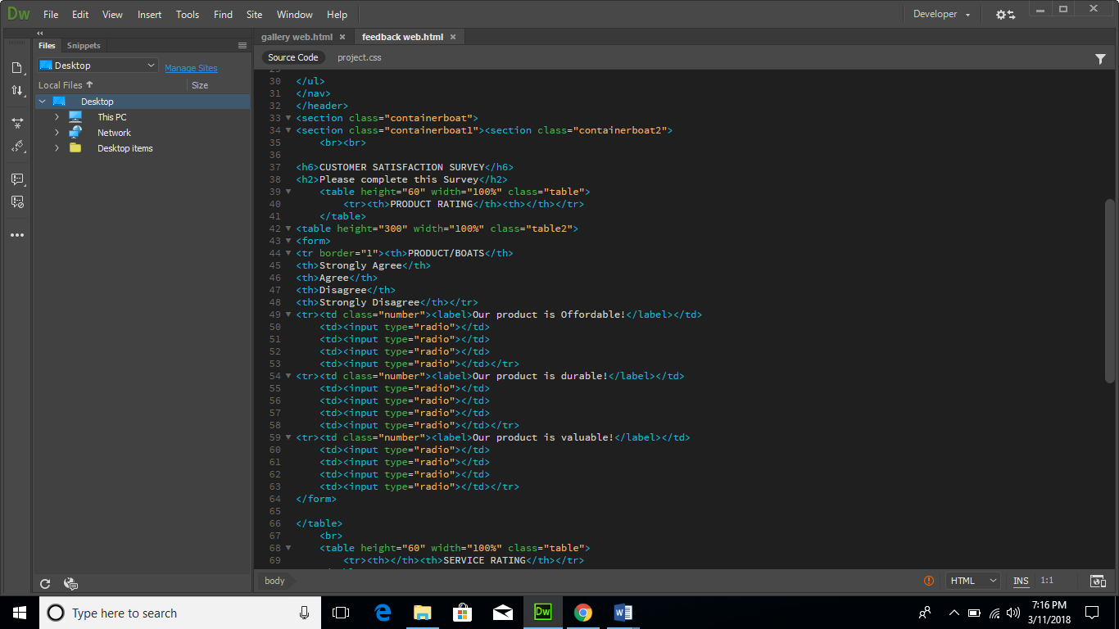

**CSS**

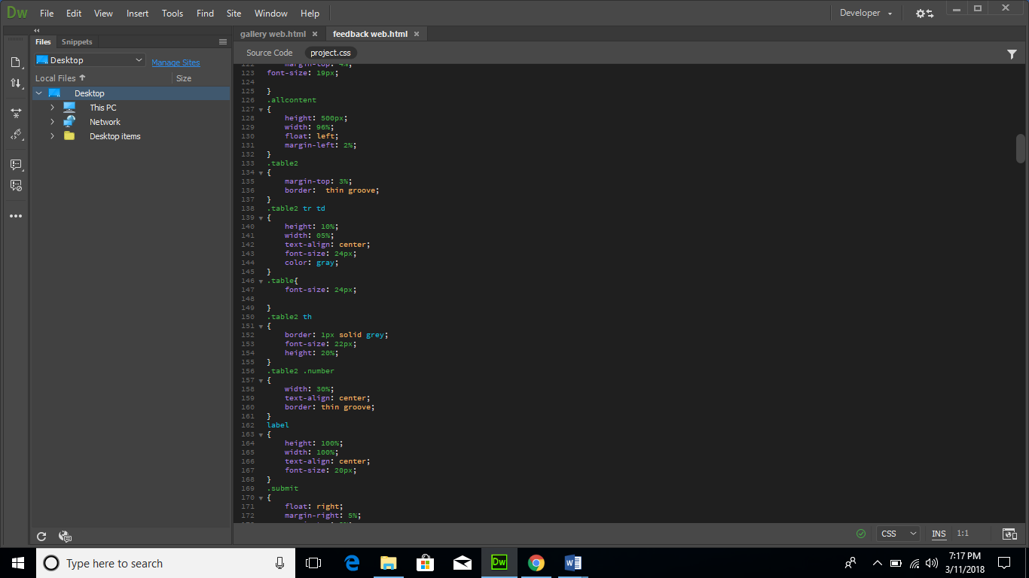

1. **ABOUT US**

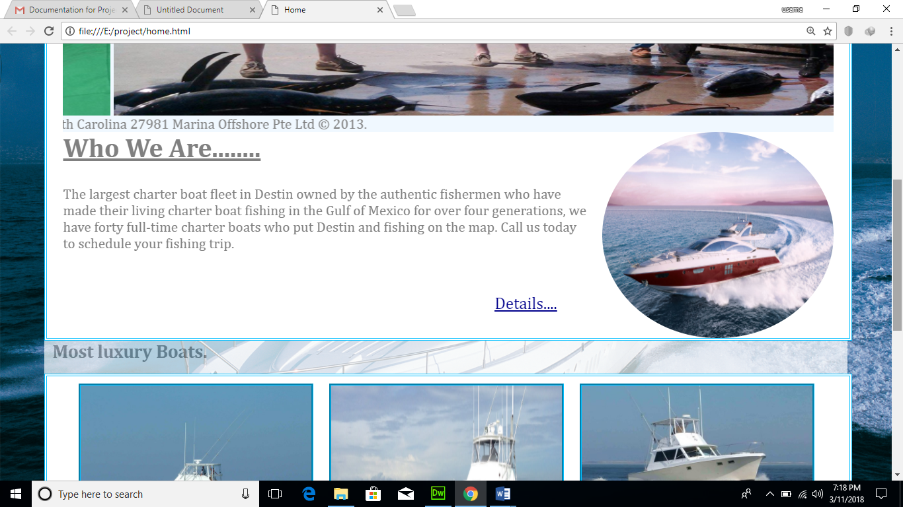

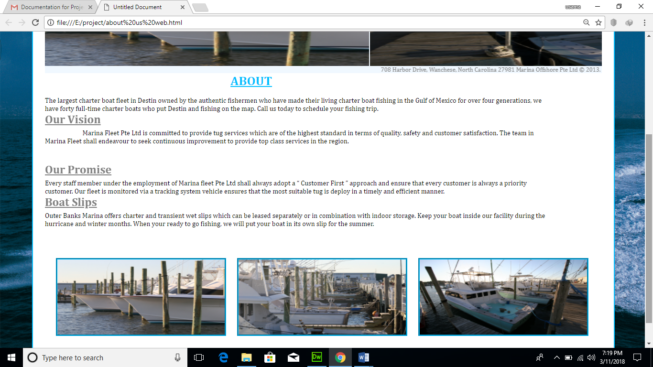

**HTML**

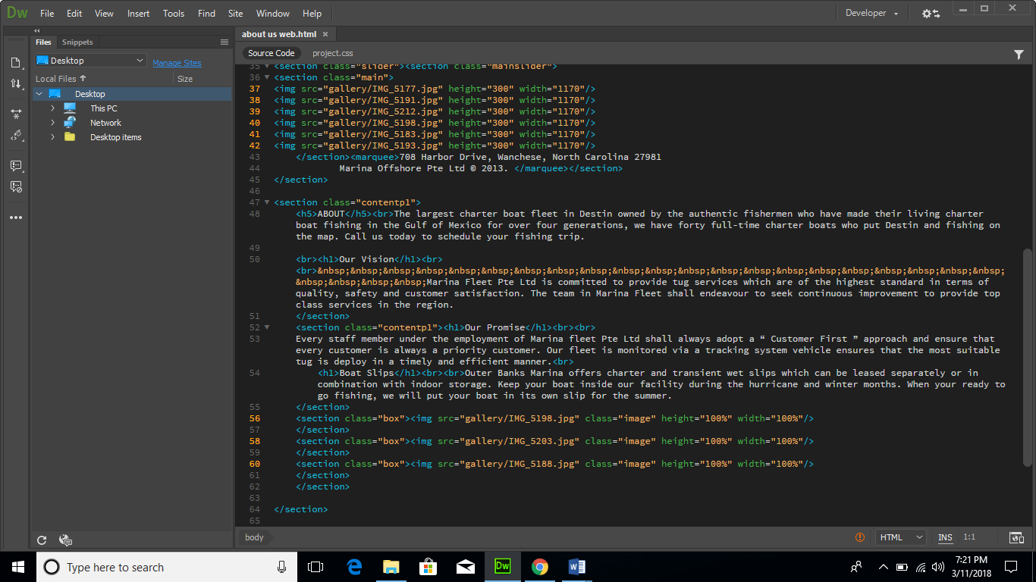

**CSS**

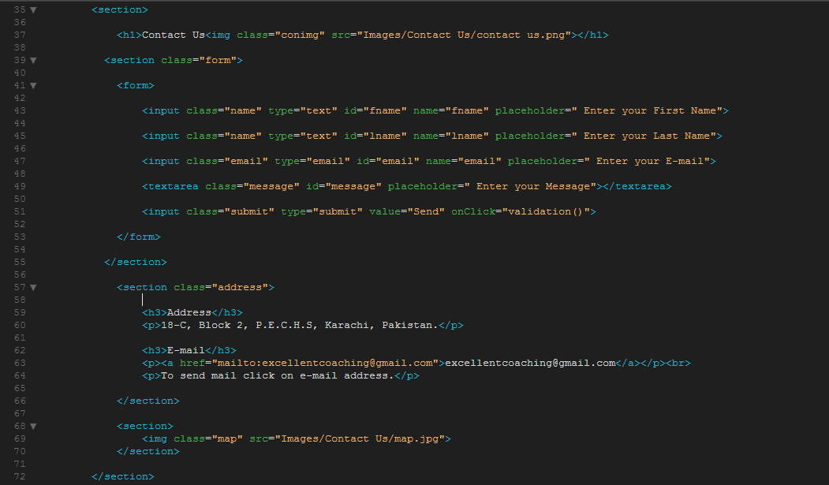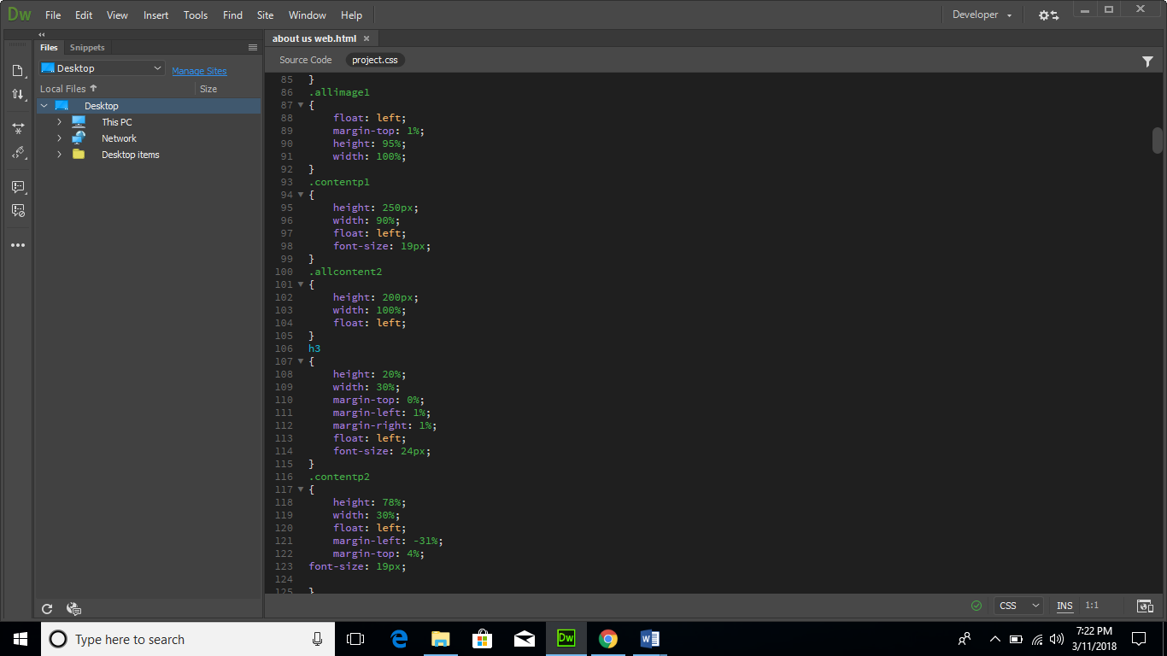

THANK YOU